**The Bridge: Website integration**

**Welcome to**

**The Bridge**

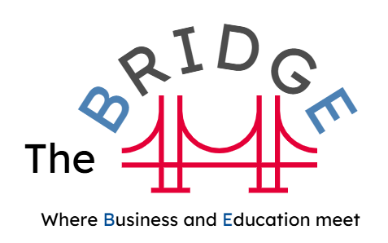At Essex County Council we are passionate about helping businesses prosper whilst also providing opportunities for young people with additional needs or disabilities to access employment opportunities. We have created a FREE matching service which helps you to identify and grow talent by creating a simple relationship between yourself and education. We call it “The Bridge” – a place where Business and Education can meet.

"Creating a relationship with your local education setting is an investment in your future workforce and business prosperity"

The Bridge provides multiple entry connection points with education (Fig 1), allowing you to connect at a level you are comfortable with. The aim is to provide you with the knowledge, training and support to become an inclusive employer, whilst also building your own talent pipeline aligned to your business needs.

Fig 1

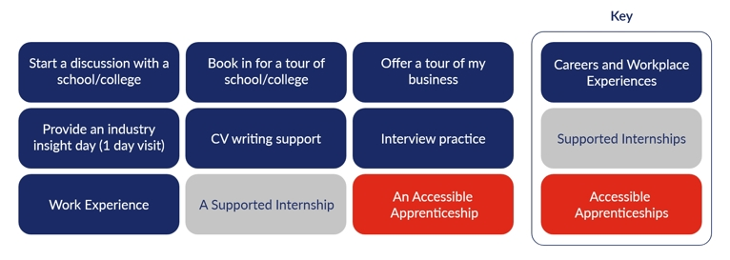

**Get started on your inclusive journey**

We use three, **fully supported** pathways to start businesses on their inclusive journey: Careers and Workplace Experiences, Supported Internships (coming soon) and Accessible Apprenticeships.

For the first time, positive Workplace experiences can be transferred into meaningful employment pathways (Supported Internships and Accessible Apprenticeships), continuing the value chain and maximising the employment outcome for a young learner and the business.

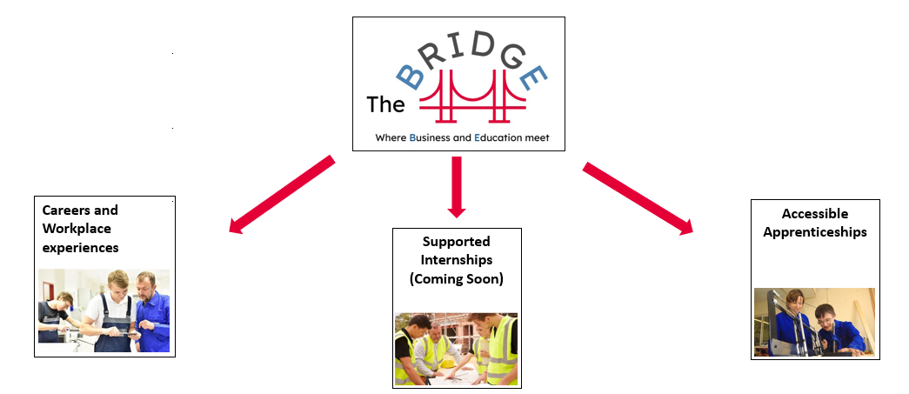

Learn more at [Welcome to The Bridge](https://www.essexopportunities.co.uk/welcome-to-the-bridge/)

And it all starts with a simple connection through The Bridge. Gain access to over 12,000+ potential employees by forging a relationship with their current education settings.

You will be matched with a local education provider AND with young people who have skills and an interest aligned to your industry area.

[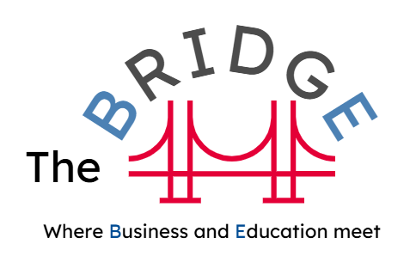](https://forms.office.com/e/MGPUCazDeU)

**Connect Now**